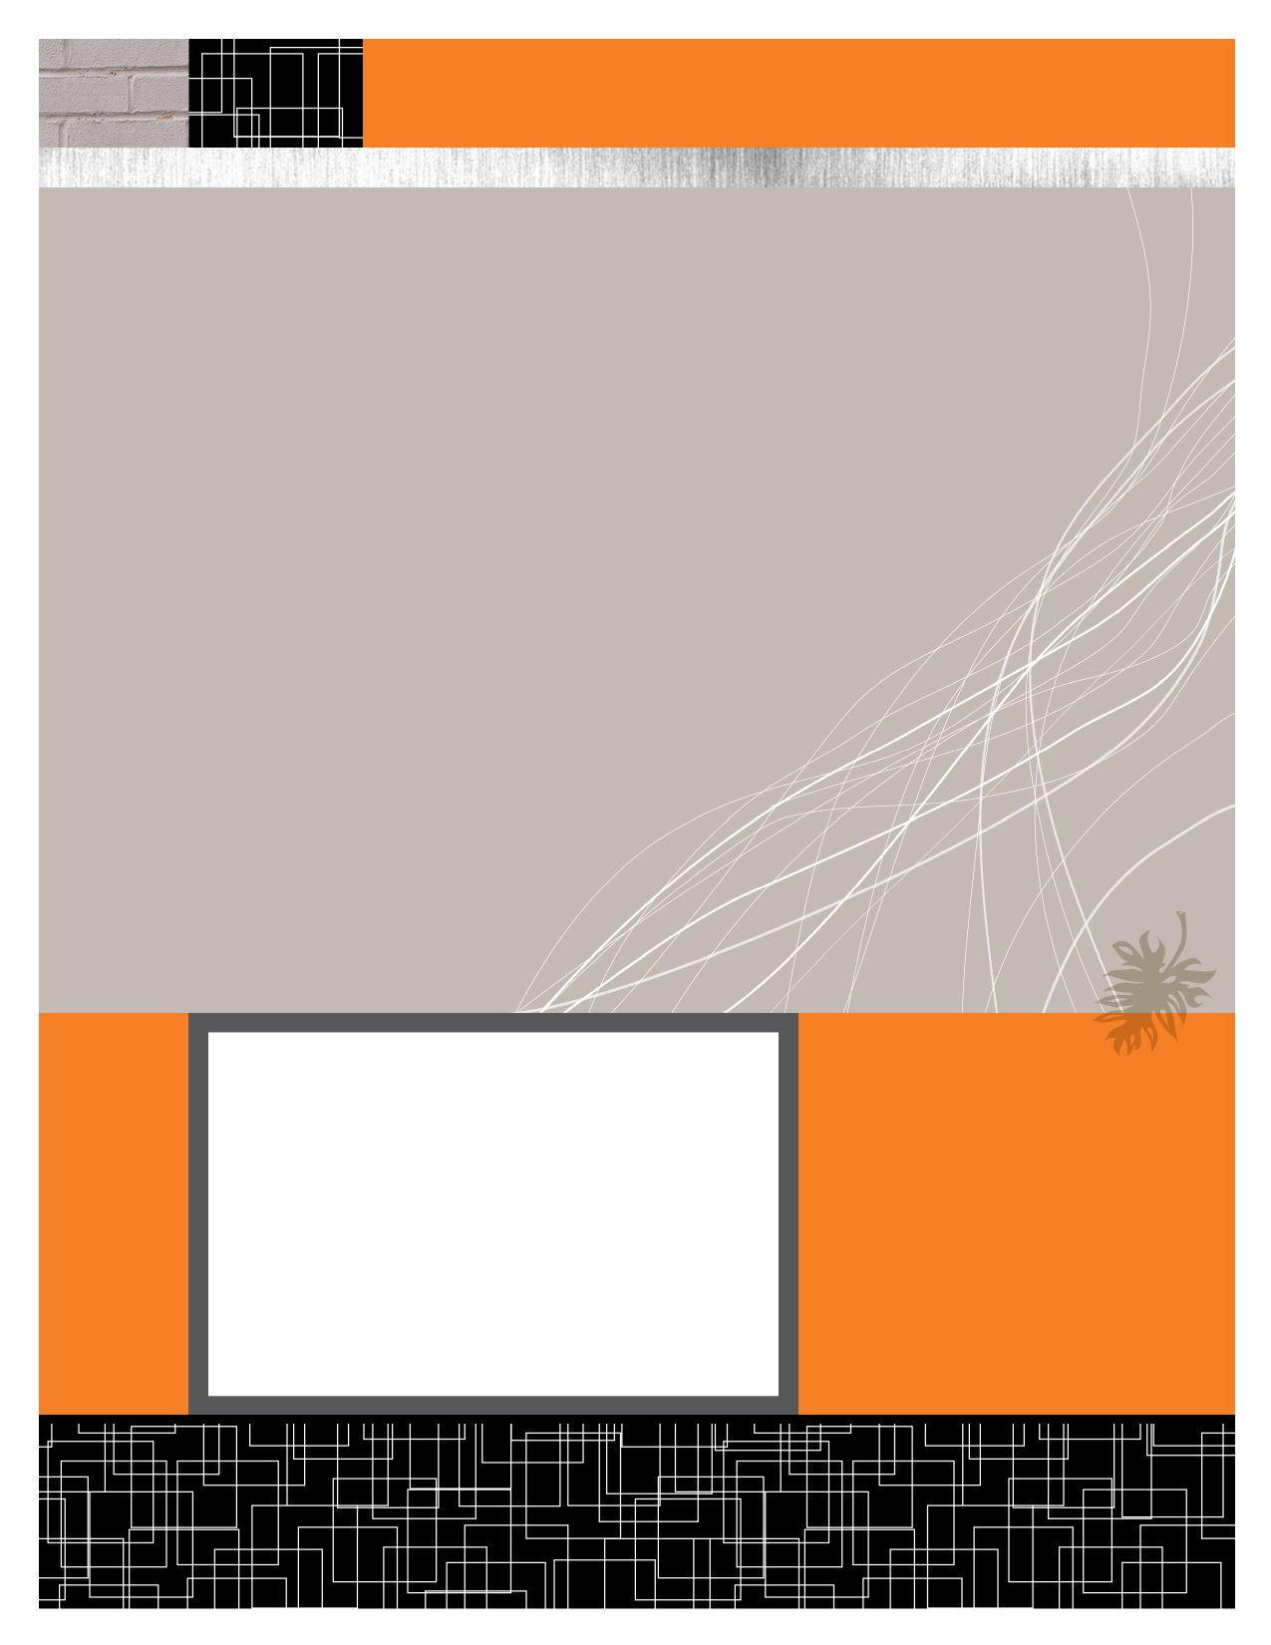

Anshul Jain (Y09UC027)

Mumal Seth (Y09UC086)

Shreya Mundra (Y09UC150)

Karan Poddar (Y09UC301)

Course Registration Portal

Class Diagrams

March 19, 2012



CLASS DIAGRAMS

